TRƯỜNG ĐẠI HỌC TÀI NGUYÊN VÀ MÔI TRƯỜNG THÀNH PHỐ HỒ CHÍ MINH (HCMUNRE)
KHOA CÔNG NGHỆ THÔNG TIN
BÁO CÁO THỰC HÀNH MÔN CƠ SỞ DỮ LIỆU NÂNG CAO
HỆ QUẢN TRỊ CƠ SỞ DỮ LIỆU ORACLE
Giảng viên hướng dẫn: ThS. Phạm Trọng Huynh
Sinh viên thực hiện: Đỗ Tiến Trí
Mã số sinh viên: 1250080208
Lớp: 12_DH_CNTT4

Buổi 4

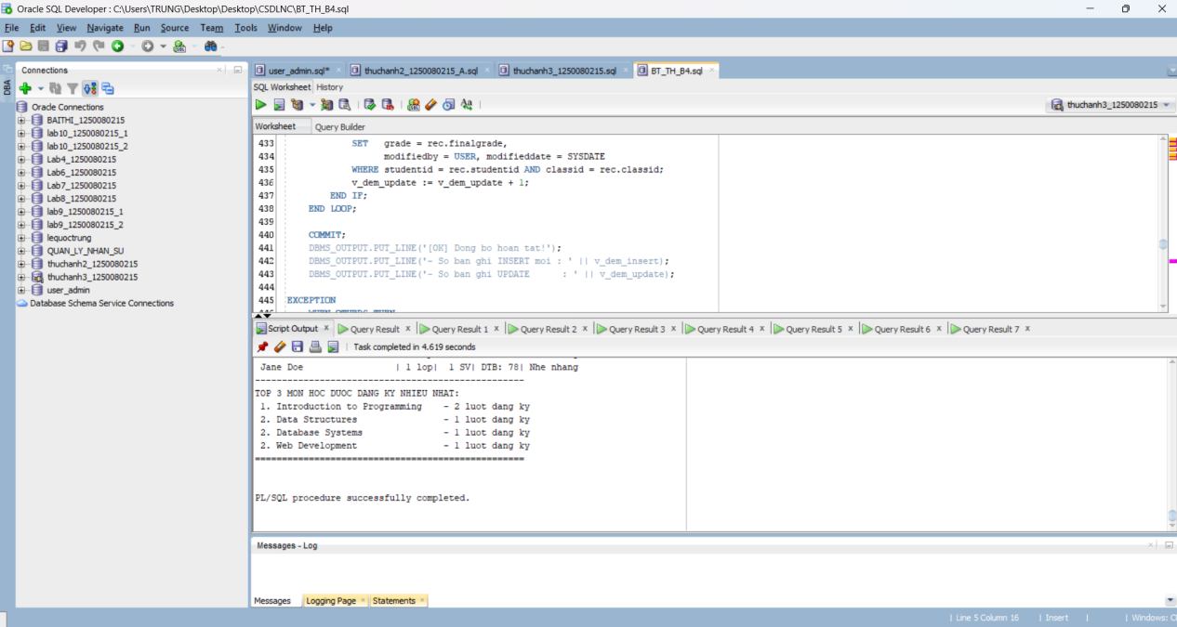

Câu 1.1: Tạo view vw_course_summary - thông tin tổng quan môn học
CREATE OR REPLACE VIEW vw_course_summary AS
SELECT co.courseno,
co.description,
co.cost,
COUNT(DISTINCT cl.classid) AS so_lop,
COUNT(e.studentid) AS tong_sv
FROM course co
LEFT JOIN class cl ON co.courseno = cl.courseno
LEFT JOIN enrollment e ON cl.classid = e.classid
GROUP BY co.courseno, co.description, co.cost
ORDER BY tong_sv DESC;

-- Kiem tra view:
SELECT * FROM vw_course_summary;
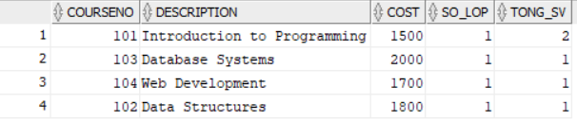

Câu 1.2: Tạo view vw_student_status - thông tin sinh viên và tình trạng học tập
CREATE OR REPLACE VIEW vw_student_status AS
SELECT s.studentid,
s.firstname || ' ' || s.lastname AS ho_ten,
COUNT(e.classid) AS so_lop_hoc,
NVL(SUM(co.cost), 0) AS tong_hoc_phi,
ROUND(AVG(e.finalgrade), 2) AS diem_tb
FROM student s
JOIN enrollment e ON s.studentid = e.studentid
JOIN class cl ON e.classid = cl.classid
JOIN course co ON cl.courseno = co.courseno
GROUP BY s.studentid, s.firstname, s.lastname
HAVING COUNT(e.classid) >= 1
ORDER BY s.studentid;

SELECT * FROM vw_student_status;
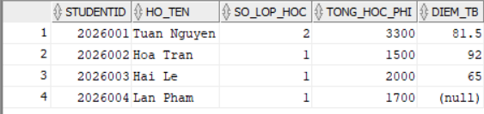

Câu 1.3: Tạo view vw_class_availability - lớp học còn chỗ trống
CREATE OR REPLACE VIEW vw_class_availability AS
SELECT cl.classid,
cl.courseno,
co.description,
i.firstname || ' ' || i.lastname AS ten_giao_vien,
cl.capacity,
COUNT(e.studentid) AS so_da_dk,
cl.capacity - COUNT(e.studentid) AS cho_trong,
CASE
WHEN cl.capacity - COUNT(e.studentid) > 0 THEN 'Con cho'
ELSE 'Het cho'
END AS trang_thai
FROM class cl
JOIN course co ON cl.courseno = co.courseno
JOIN instructor i ON cl.instructorid = i.instructorid
LEFT JOIN enrollment e ON cl.classid = e.classid
GROUP BY cl.classid, cl.courseno, co.description,
i.firstname, i.lastname, cl.capacity
HAVING cl.capacity - COUNT(e.studentid) > 0
ORDER BY cl.classid;
SELECT * FROM vw_class_availability;
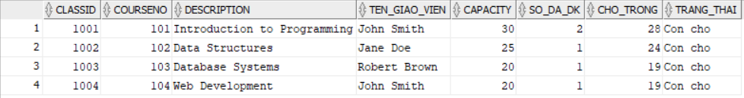

Câu 1.4: Tạo view vw_top_courses - chỉ đọc, top 5 môn được đăng ký nhiều nhất
CREATE OR REPLACE VIEW vw_top_courses AS
SELECT courseno, description, cost, tong_dk, hang
FROM (
SELECT co.courseno,
co.description,
co.cost,
COUNT(e.studentid) AS tong_dk,
RANK() OVER (ORDER BY COUNT(e.studentid) DESC) AS hang
FROM course co
LEFT JOIN class cl ON co.courseno = cl.courseno
LEFT JOIN enrollment e ON cl.classid = e.classid
GROUP BY co.courseno, co.description, co.cost
)
WHERE hang <= 5
ORDER BY hang
WITH READ ONLY;

SELECT * FROM vw_top_courses;

-- Thu INSERT vao view nay (se bao loi ORA-42399):
INSERT INTO vw_top_courses (courseno, description, cost)
VALUES (999, 'Test', 100);
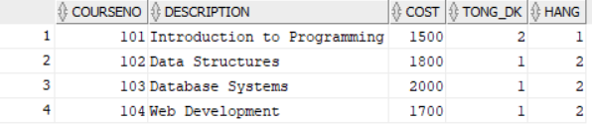

Câu 1.5: Tạo view vw_pending_enrollment với WITH CHECK OPTION và kiểm tra
CREATE OR REPLACE VIEW vw_pending_enrollment AS
SELECT studentid, classid, enrolldate, finalgrade,
createdby, createddate, modifiedby, modifieddate
FROM enrollment
WHERE finalgrade IS NULL
WITH CHECK OPTION;

SELECT * FROM vw_pending_enrollment;
-- INSERT 1: FinalGrade = NULL -> THANH CONG (thoa dieu kien WHERE)
INSERT INTO vw_pending_enrollment
(studentid, classid, enrolldate, createdby, createddate,
modifiedby, modifieddate)
VALUES (999, 1, SYSDATE, USER, SYSDATE, USER, SYSDATE);

-- INSERT 2: FinalGrade = 85 -> LOI ORA-01402 (vi pham WITH CHECK OPTION)
INSERT INTO vw_pending_enrollment
(studentid, classid, enrolldate, finalgrade,
createdby, createddate, modifiedby, modifieddate)
VALUES (998, 1, SYSDATE, 85, USER, SYSDATE, USER, SYSDATE);

Câu 2.1: Thủ tục enroll_student - đăng ký sinh viên vào lớp học
CREATE OR REPLACE PROCEDURE enroll_student
(p_studentid IN NUMBER,
p_classid IN NUMBER)
IS
v_check NUMBER;
v_capacity NUMBER;
v_enrolled NUMBER;
BEGIN
-- DK1: Sinh vien phai ton tai
SELECT COUNT(*) INTO v_check FROM student WHERE studentid = p_studentid;
IF v_check = 0 THEN
DBMS_OUTPUT.PUT_LINE('[LOI] Sinh vien ' || p_studentid || ' khong ton tai!');
RETURN;
END IF;

-- DK2: Lop hoc phai ton tai
SELECT COUNT(*) INTO v_check FROM class WHERE classid = p_classid;
IF v_check = 0 THEN
DBMS_OUTPUT.PUT_LINE('[LOI] Lop hoc ' || p_classid || ' khong ton tai!');
RETURN;
END IF;

-- DK3: Kiem tra con cho trong
SELECT capacity INTO v_capacity FROM class WHERE classid = p_classid;
SELECT COUNT(*) INTO v_enrolled FROM enrollment WHERE classid = p_classid;
IF v_enrolled >= v_capacity THEN
DBMS_OUTPUT.PUT_LINE('[LOI] Lop ' || p_classid || ' da day! (' || v_enrolled || '/' || v_capacity || ')');
RETURN;
END IF;

-- DK4: Sinh vien chua dang ky lop nay
SELECT COUNT(*) INTO v_check FROM enrollment
WHERE studentid = p_studentid AND classid = p_classid;
IF v_check > 0 THEN
DBMS_OUTPUT.PUT_LINE('[LOI] Sinh vien da dang ky lop nay roi!');
RETURN;
END IF;

-- DK5: Sinh vien chua qua 3 lop
SELECT COUNT(*) INTO v_check FROM enrollment WHERE studentid = p_studentid;
IF v_check >= 3 THEN
DBMS_OUTPUT.PUT_LINE('[LOI] Sinh vien da dang ky du 3 lop!');
RETURN;
END IF;

-- Tat ca OK: INSERT
INSERT INTO enrollment
(studentid, classid, enrolldate, createdby, createddate, modifiedby, modifieddate)
VALUES
(p_studentid, p_classid, SYSDATE, USER, SYSDATE, USER, SYSDATE);

COMMIT;
DBMS_OUTPUT.PUT_LINE('[OK] Dang ky thanh cong! SV ' || p_studentid || ' -> Lop ' || p_classid);

EXCEPTION
WHEN OTHERS THEN
ROLLBACK;
DBMS_OUTPUT.PUT_LINE('[LOI HE THONG] ' || SQLERRM);
END enroll_student;
/

-- Kiem tra:
BEGIN
enroll_student(101, 5); -- Hop le
enroll_student(999, 5); -- SV khong ton tai
enroll_student(101, 999); -- Lop khong ton tai
END;
/
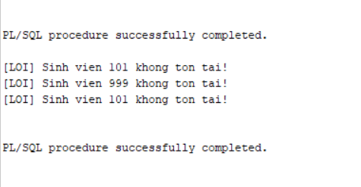

Câu 2.2: Thủ tục update_final_grade - cập nhật điểm tổng kết
CREATE OR REPLACE PROCEDURE update_final_grade
(p_studentid IN NUMBER,
p_classid IN NUMBER,
p_grade IN NUMBER)
IS
v_check NUMBER;
v_old_grade NUMBER;
BEGIN
-- Kiem tra diem hop le
IF p_grade < 0 OR p_grade > 100 THEN
DBMS_OUTPUT.PUT_LINE('[LOI] Diem khong hop le! Phai tu 0 den 100.');
RETURN;
END IF;

-- Kiem tra cap (StudentID, ClassID) ton tai trong ENROLLMENT
SELECT COUNT(*) INTO v_check FROM enrollment
WHERE studentid = p_studentid AND classid = p_classid;

IF v_check = 0 THEN
DBMS_OUTPUT.PUT_LINE('[LOI] Sinh vien chua dang ky lop nay!');
RETURN;
END IF;

-- Luu diem cu
SELECT finalgrade INTO v_old_grade FROM enrollment
WHERE studentid = p_studentid AND classid = p_classid;

-- Cap nhat ENROLLMENT
UPDATE enrollment
SET finalgrade = p_grade,
modifiedby = USER, modifieddate = SYSDATE
WHERE studentid = p_studentid AND classid = p_classid;

-- Dong bo sang bang GRADE bang MERGE INTO
MERGE INTO grade g
USING (SELECT p_studentid AS sid, p_classid AS cid FROM DUAL) src
ON (g.studentid = src.sid AND g.classid = src.cid)
WHEN MATCHED THEN
UPDATE SET g.grade = p_grade,
g.modifiedby = USER, g.modifieddate = SYSDATE
WHEN NOT MATCHED THEN
INSERT (studentid, classid, grade, createdby, createddate,
modifiedby, modifieddate)
VALUES (p_studentid, p_classid, p_grade,
USER, SYSDATE, USER, SYSDATE);

COMMIT;
DBMS_OUTPUT.PUT_LINE('[OK] Da cap nhat diem SV ' || p_studentid
|| ' lop ' || p_classid
|| ': Cu=' || NVL(TO_CHAR(v_old_grade),'NULL')
|| ' -> Moi=' || p_grade);

EXCEPTION
WHEN OTHERS THEN
ROLLBACK;
DBMS_OUTPUT.PUT_LINE('[LOI] ' || SQLERRM);
END update_final_grade;
/
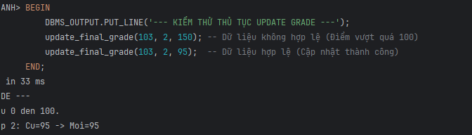

Câu 2.3: Thủ tục transfer_student - chuyển lớp cho sinh viên
CREATE OR REPLACE PROCEDURE transfer_student
(p_studentid IN NUMBER,
p_old_classid IN NUMBER,
p_new_classid IN NUMBER)
IS
v_check NUMBER;
v_capacity NUMBER;
v_enrolled NUMBER;
BEGIN
-- DK1: Sinh vien dang hoc o lop cu
SELECT COUNT(*) INTO v_check FROM enrollment
WHERE studentid = p_studentid AND classid = p_old_classid;

IF v_check = 0 THEN
DBMS_OUTPUT.PUT_LINE('[LOI] Sinh vien khong dang hoc lop ' || p_old_classid);
RETURN;
END IF;

-- DK2: Lop moi con cho trong
SELECT capacity INTO v_capacity FROM class WHERE classid = p_new_classid;

SELECT COUNT(*) INTO v_enrolled FROM enrollment WHERE classid = p_new_classid;

IF v_enrolled >= v_capacity THEN
DBMS_OUTPUT.PUT_LINE('[LOI] Lop moi ' || p_new_classid || ' da day!');
RETURN;
END IF;

-- DK3: Sinh vien chua dang ky lop moi
SELECT COUNT(*) INTO v_check FROM enrollment
WHERE studentid = p_studentid AND classid = p_new_classid;

IF v_check > 0 THEN
DBMS_OUTPUT.PUT_LINE('[LOI] Sinh vien da o trong lop moi roi!');
RETURN;
END IF;

-- Tat ca OK: thuc hien chuyen lop
SAVEPOINT sp_truoc_chuyen;

-- Buoc 1: Xoa khoi lop cu
DELETE FROM enrollment
WHERE studentid = p_studentid AND classid = p_old_classid;

SAVEPOINT sp_sau_xoa;

-- Buoc 2: Them vao lop moi
INSERT INTO enrollment
(studentid, classid, enrolldate, createdby, createddate,
modifiedby, modifieddate)
VALUES
(p_studentid, p_new_classid, SYSDATE, USER, SYSDATE, USER, SYSDATE);

COMMIT;
DBMS_OUTPUT.PUT_LINE('[OK] Da chuyen SV ' || p_studentid
|| ' tu lop ' || p_old_classid
|| ' sang lop ' || p_new_classid);

EXCEPTION
WHEN OTHERS THEN
ROLLBACK TO sp_truoc_chuyen;
DBMS_OUTPUT.PUT_LINE('[LOI] Chuyen lop that bai: ' || SQLERRM);
DBMS_OUTPUT.PUT_LINE('Da rollback ve trang thai ban dau.');
END transfer_student;
/
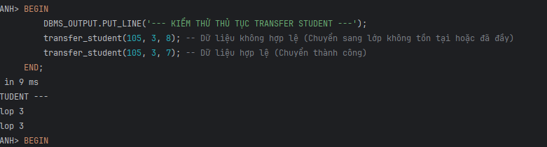

Câu 2.4: Thủ tục report_class_detail — in báo cáo chi tiết lớp học
CREATE OR REPLACE PROCEDURE report_class_detail
(p_classid IN NUMBER)
IS
v_check NUMBER;
v_course VARCHAR2(50);
v_courseno NUMBER;
v_gv VARCHAR2(50);
v_loc VARCHAR2(50);
v_cap NUMBER;
v_stt NUMBER := 0;
v_tong NUMBER := 0;
v_sum_d NUMBER := 0;
v_co_d NUMBER := 0;
v_grade_txt VARCHAR2(15);
BEGIN
-- Kiem tra lop ton tai
SELECT COUNT(*) INTO v_check FROM class WHERE classid = p_classid;

IF v_check = 0 THEN
DBMS_OUTPUT.PUT_LINE('Lop hoc ' || p_classid || ' khong ton tai!');
RETURN;
END IF;

-- Lay thong tin lop
SELECT co.description, co.courseno,
i.firstname || ' ' || i.lastname,
cl.location, cl.capacity
INTO v_course, v_courseno, v_gv, v_loc, v_cap
FROM class cl
JOIN course co ON cl.courseno = co.courseno
JOIN instructor i ON cl.instructorid = i.instructorid
WHERE cl.classid = p_classid;

-- In header bao cao
DBMS_OUTPUT.PUT_LINE('=== BAO CAO LOP HOC: ' || p_classid || ' ===');
DBMS_OUTPUT.PUT_LINE('Mon hoc : ' || v_courseno || ' - ' || v_course);
DBMS_OUTPUT.PUT_LINE('Giao vien: ' || v_gv);
DBMS_OUTPUT.PUT_LINE('Phong hoc: ' || NVL(v_loc, 'Chua xep phong'));
DBMS_OUTPUT.PUT_LINE('Suc chua : ' || v_cap || ' cho');
DBMS_OUTPUT.PUT_LINE(RPAD('-', 50, '-'));
DBMS_OUTPUT.PUT_LINE('DANH SACH SINH VIEN:');
DBMS_OUTPUT.PUT_LINE(RPAD('STT', 4) || '|' || RPAD('Ho Ten', 20)
|| '|' || LPAD('Diem TK', 8) || '|' || ' Xep loai');
DBMS_OUTPUT.PUT_LINE(RPAD('-', 50, '-'));

-- Duyet danh sach sinh vien
FOR rec IN (
SELECT s.firstname || ' ' || s.lastname AS ho_ten,
e.finalgrade
FROM enrollment e
JOIN student s ON e.studentid = s.studentid
WHERE e.classid = p_classid
ORDER BY s.lastname, s.firstname
) LOOP
v_stt := v_stt + 1;
v_tong := v_tong + 1;

-- Xep loai
IF rec.finalgrade IS NULL THEN
v_grade_txt := 'Chua co diem';
ELSIF rec.finalgrade >= 90 THEN
v_grade_txt := 'A';
v_sum_d := v_sum_d + rec.finalgrade; v_co_d := v_co_d + 1;
ELSIF rec.finalgrade >= 80 THEN
v_grade_txt := 'B';
v_sum_d := v_sum_d + rec.finalgrade; v_co_d := v_co_d + 1;
ELSIF rec.finalgrade >= 70 THEN
v_grade_txt := 'C';
v_sum_d := v_sum_d + rec.finalgrade; v_co_d := v_co_d + 1;
ELSIF rec.finalgrade >= 50 THEN
v_grade_txt := 'D';
v_sum_d := v_sum_d + rec.finalgrade; v_co_d := v_co_d + 1;
ELSE
v_grade_txt := 'F';
v_sum_d := v_sum_d + rec.finalgrade; v_co_d := v_co_d + 1;
END IF;

DBMS_OUTPUT.PUT_LINE(
LPAD(v_stt, 3) || ' | '
|| RPAD(rec.ho_ten, 20) || ' | '
|| LPAD(NVL(TO_CHAR(rec.finalgrade), 'NULL'), 7) || ' | '
|| v_grade_txt
);
END LOOP;

-- In footer bao cao
DBMS_OUTPUT.PUT_LINE(RPAD('-', 50, '-'));
DBMS_OUTPUT.PUT_LINE('Tong so sinh vien : ' || v_tong);

IF v_co_d > 0 THEN
DBMS_OUTPUT.PUT_LINE('Diem trung binh lop: '
|| ROUND(v_sum_d / v_co_d, 2));
ELSE
DBMS_OUTPUT.PUT_LINE('Diem trung binh lop: Chua co diem');
END IF;

END report_class_detail;
/

-- Goi thu tuc:
BEGIN
report_class_detail(1);
END;
/
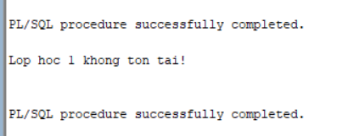

Câu 2.5: Thủ tục sync_grade_from_enrollment - đồng bộ điểm từ ENROLLMENT sang GRADE
CREATE OR REPLACE PROCEDURE sync_grade_from_enrollment
IS
v_check NUMBER;
v_dem_insert NUMBER := 0;
v_dem_update NUMBER := 0;
BEGIN
FOR rec IN (
SELECT studentid, classid, finalgrade
FROM enrollment
WHERE finalgrade IS NOT NULL
) LOOP
-- Kiem tra trong GRADE da co chua
SELECT COUNT(*) INTO v_check FROM grade
WHERE studentid = rec.studentid AND classid = rec.classid;
IF v_check = 0 THEN
-- Chua co -> INSERT moi
INSERT INTO grade
(studentid, classid, grade, createdby, createddate,
modifiedby, modifieddate)
VALUES
(rec.studentid, rec.classid, rec.finalgrade,
USER, SYSDATE, USER, SYSDATE);
v_dem_insert := v_dem_insert + 1;
ELSE
-- Da co -> UPDATE
UPDATE grade
SET grade = rec.finalgrade,
modifiedby = USER, modifieddate = SYSDATE
WHERE studentid = rec.studentid AND classid = rec.classid;
v_dem_update := v_dem_update + 1;
END IF;
END LOOP;
COMMIT;
DBMS_OUTPUT.PUT_LINE('[OK] Dong bo hoan tat!');
DBMS_OUTPUT.PUT_LINE('- So ban ghi INSERT moi : ' || v_dem_insert);
DBMS_OUTPUT.PUT_LINE('- So ban ghi UPDATE : ' || v_dem_update);
EXCEPTION
WHEN OTHERS THEN
ROLLBACK;
DBMS_OUTPUT.PUT_LINE('[LOI] ' || SQLERRM);
END sync_grade_from_enrollment;
/
BEGIN sync_grade_from_enrollment;
END;
/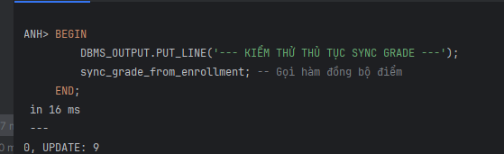

Câu 3.1: Trigger trg_check_capacity - kiểm tra sức chứa khi đăng ký
CREATE OR REPLACE TRIGGER trg_check_capacity
BEFORE INSERT ON enrollment
FOR EACH ROW
DECLARE
v_capacity NUMBER;
v_enrolled NUMBER;
BEGIN
-- Lay suc chua lop hoc
SELECT capacity INTO v_capacity
FROM class WHERE classid = :NEW.classid;
-- Dem so SV hien da dang ky
SELECT COUNT(*) INTO v_enrolled
FROM enrollment WHERE classid = :NEW.classid;
-- Tu choi neu lop da day
IF v_enrolled >= v_capacity THEN
RAISE_APPLICATION_ERROR(
-20010,
'LOI: Lop ' || :NEW.classid || ' da day! ('
|| v_enrolled || '/' || v_capacity || ' cho)'
);
END IF;
END trg_check_capacity;
/
-- Kiem tra trigger (dang ky vao lop da day):
INSERT INTO enrollment
(studentid, classid, enrolldate, createdby, createddate,
modifiedby, modifieddate)
VALUES (999, 1, SYSDATE, USER, SYSDATE, USER, SYSDATE);
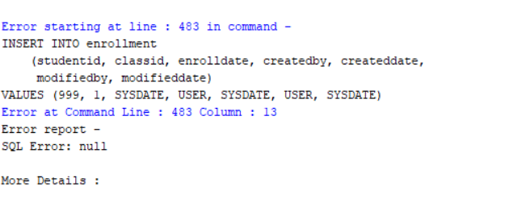

Câu 3.2: Trigger trg_grade_audit_log - ghi nhật ký thay đổi điểm
CREATE TABLE grade_audit_log (
log_id NUMBER GENERATED ALWAYS AS IDENTITY,
studentid NUMBER(8),
classid NUMBER(8),
grade_cu NUMBER(3),
grade_moi NUMBER(3),
nguoi_sua VARCHAR2(30),
thoi_gian DATE
);
/
CREATE OR REPLACE TRIGGER trg_grade_audit_log
AFTER UPDATE OF finalgrade ON enrollment
FOR EACH ROW
BEGIN
-- Chi ghi log khi diem THUC SU thay doi
IF (:OLD.finalgrade IS NULL AND :NEW.finalgrade IS NOT NULL)
OR (:OLD.finalgrade IS NOT NULL AND :NEW.finalgrade IS NULL)
OR (:OLD.finalgrade != :NEW.finalgrade)
THEN
INSERT INTO grade_audit_log
(studentid, classid, grade_cu, grade_moi, nguoi_sua, thoi_gian)
VALUES
(:OLD.studentid, :OLD.classid, :OLD.finalgrade,
:NEW.finalgrade, USER, SYSDATE);
END IF;
END trg_grade_audit_log;
/
-- Kiem tra trigger:
UPDATE enrollment SET finalgrade = 85
WHERE studentid = 101 AND classid = 1;
COMMIT;
SELECT * FROM grade_audit_log;

Câu 3.3: Trigger trg_prevent_course_delete - ngăn xóa môn học đang có lớp
CREATE OR REPLACE TRIGGER trg_prevent_course_delete
BEFORE DELETE ON course
FOR EACH ROW
DECLARE
v_so_lop NUMBER;
BEGIN
SELECT COUNT(*) INTO v_so_lop
FROM class WHERE courseno = :OLD.courseno;

IF v_so_lop > 0 THEN
RAISE_APPLICATION_ERROR(
-20020,
'Khong the xoa mon hoc ' || :OLD.courseno ||
' (' || :OLD.description || ')' ||
' vi con ' || v_so_lop || ' lop hoc dang ton tai!'
);
END IF;
-- Neu v_so_lop = 0: trigger ket thuc binh thuong, Oracle tien hanh xoa
END trg_prevent_course_delete;
/

-- Kiem tra: xoa mon co lop (se bao loi)
DELETE FROM course WHERE courseno = 10;

-- Kiem tra: xoa mon khong co lop (thanh cong)
DELETE FROM course WHERE courseno = 999; -- Mon khong co lop nao
ROLLBACK;

Câu 3.4: Trigger trg_update_grade_summary - cập nhật bảng thống kê tự động
CREATE TABLE class_grade_summary (
classid NUMBER(8) PRIMARY KEY,
so_sv NUMBER,
diem_tb NUMBER(5,2),
diem_cao_nhat NUMBER(3),
diem_thap_nhat NUMBER(3),
cap_nhat_luc DATE
);
/
CREATE OR REPLACE TRIGGER trg_update_grade_summary
AFTER INSERT OR UPDATE OR DELETE ON enrollment
FOR EACH ROW
DECLARE
v_classid NUMBER;
v_so_sv NUMBER;
v_diem_tb NUMBER;
v_max_d NUMBER;
v_min_d NUMBER;
BEGIN
-- Lay ClassID dua tren loai su kien
IF INSERTING OR UPDATING THEN
v_classid := :NEW.classid;
ELSE -- DELETING
v_classid := :OLD.classid;
END IF;
-- Tinh lai thong ke cho lop bi anh huong
SELECT COUNT(finalgrade),
ROUND(AVG(finalgrade), 2),
MAX(finalgrade),
MIN(finalgrade)
INTO v_so_sv, v_diem_tb, v_max_d, v_min_d
FROM enrollment
WHERE classid = v_classid AND finalgrade IS NOT NULL;
-- MERGE INTO cap nhat hoac them moi
MERGE INTO class_grade_summary cgs
USING (SELECT v_classid AS cid FROM DUAL) src
ON (cgs.classid = src.cid)
WHEN MATCHED THEN
UPDATE SET
so_sv = v_so_sv,
diem_tb = v_diem_tb,
diem_cao_nhat = v_max_d,
diem_thap_nhat = v_min_d,
cap_nhat_luc = SYSDATE
WHEN NOT MATCHED THEN
INSERT (classid, so_sv, diem_tb, diem_cao_nhat, diem_thap_nhat, cap_nhat_luc)
VALUES (v_classid, v_so_sv, v_diem_tb, v_max_d, v_min_d, SYSDATE);
END trg_update_grade_summary;
/
-- Kiem tra trigger:
UPDATE enrollment SET finalgrade = 90 WHERE studentid = 101 AND classid = 1;
COMMIT;
SELECT * FROM class_grade_summary WHERE classid = 1;

Câu 4.1: Hệ thống báo cáo hoàn chỉnh - View + Procedure + Cursor
-- Bước 1: Tạo view vw_instructor_workload:
CREATE OR REPLACE VIEW vw_instructor_workload AS
SELECT i.instructorid,
i.firstname || ' ' || i.lastname AS ho_ten,
COUNT(DISTINCT cl.classid) AS so_lop,
COUNT(e.studentid) AS tong_sv,
ROUND(AVG(e.finalgrade), 2) AS diem_tb_chung,
CASE
WHEN COUNT(DISTINCT cl.classid) >= 3 THEN 'Ban nhieu'
WHEN COUNT(DISTINCT cl.classid) = 2 THEN 'Binh thuong'
ELSE 'Nhe nhang'
END AS muc_ban
FROM instructor i
LEFT JOIN class cl ON i.instructorid = cl.instructorid
LEFT JOIN enrollment e ON cl.classid = e.classid
GROUP BY i.instructorid, i.firstname, i.lastname
ORDER BY so_lop DESC;

SELECT * FROM vw_instructor_workload;
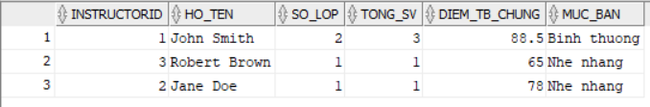
-- Bước 2: Thủ tục print_system_report:
CREATE OR REPLACE PROCEDURE print_system_report
IS
v_so_mon NUMBER;
v_so_lop NUMBER;
v_so_sv NUMBER;
v_so_gv NUMBER;
BEGIN
-- Lay so lieu tong the
SELECT COUNT(*) INTO v_so_mon FROM course;
SELECT COUNT(*) INTO v_so_lop FROM class;
SELECT COUNT(*) INTO v_so_sv FROM student;
SELECT COUNT(*) INTO v_so_gv FROM instructor;

-- In header
DBMS_OUTPUT.PUT_LINE('==================================================');
DBMS_OUTPUT.PUT_LINE(' BAO CAO TOAN HE THONG QUAN LY KHOA HOC');
DBMS_OUTPUT.PUT_LINE('==================================================');
DBMS_OUTPUT.PUT_LINE('Tong so mon hoc : ' || v_so_mon);
DBMS_OUTPUT.PUT_LINE('Tong so lop hoc : ' || v_so_lop);
DBMS_OUTPUT.PUT_LINE('Tong so sinh vien: ' || v_so_sv);
DBMS_OUTPUT.PUT_LINE('Tong so giao vien: ' || v_so_gv);
DBMS_OUTPUT.PUT_LINE(RPAD('-', 50, '-'));

-- Phan 1: Thong ke giao vien (dung view vw_instructor_workload)
DBMS_OUTPUT.PUT_LINE('THONG KE GIAO VIEN:');
FOR rec IN (SELECT * FROM vw_instructor_workload) LOOP
DBMS_OUTPUT.PUT_LINE(
' ' || RPAD(rec.ho_ten, 25)
|| '|' || LPAD(rec.so_lop, 2) || ' lop'
|| '|' || LPAD(rec.tong_sv, 3) || ' SV'
|| '| DTB: ' || NVL(TO_CHAR(rec.diem_tb_chung), '--')
|| '| ' || rec.muc_ban
);
END LOOP;
DBMS_OUTPUT.PUT_LINE(RPAD('-', 50, '-'));

-- Phan 2: Top 3 mon hoc (dung view vw_top_courses)
DBMS_OUTPUT.PUT_LINE('TOP 3 MON HOC DUOC DANG KY NHIEU NHAT:');
FOR rec IN (SELECT * FROM vw_top_courses WHERE hang <= 3) LOOP
DBMS_OUTPUT.PUT_LINE(
' ' || rec.hang || '. '
|| RPAD(rec.description, 30)
|| ' - ' || rec.tong_dk || ' luot dang ky'
);
END LOOP;

DBMS_OUTPUT.PUT_LINE('==================================================');
END print_system_report;
/

-- Chay bao cao:
SET SERVEROUTPUT ON SIZE 1000000;
BEGIN print_system_report; END;
/
